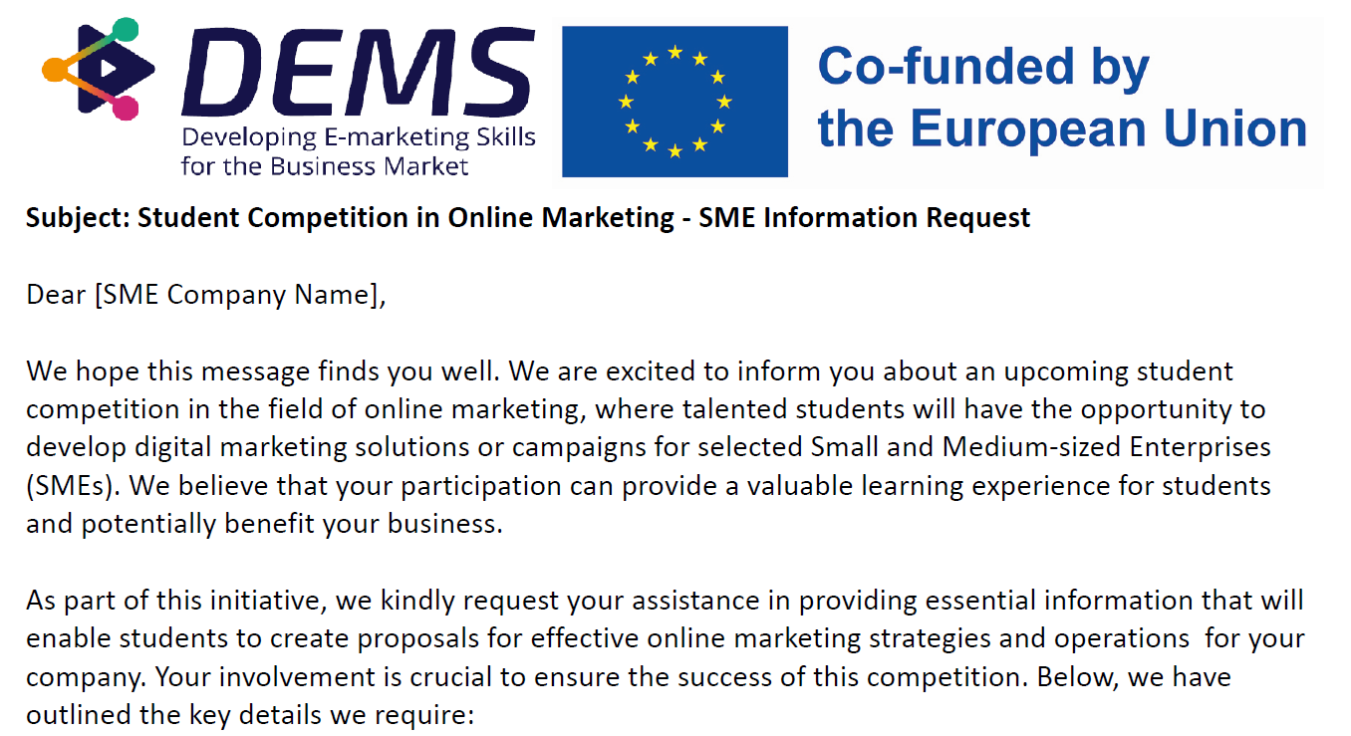
The company:
1. The company: Pictue Oy, develops automated photo documentation solutions www.pictue.com
2. Business: SaaS services
3. Target audience: Our main target groups are infrastructure construction and the municipal sector
4. Services/products offered: Pictue service, mobile app + web interface

Current web presence:
- Current web-activities: We've run a test for digital customer acquisition in the UK and at home. Platforms tested: Google Ads, LinkedIn, Facebook. The budget used for the test was around 60.000€.
- www site: https://pictue.com
- Social media: https://www.linkedin.com/company/83029301
https://www.facebook.com/pictueofficial

Marketing goals
1. Our marketing objectives are to generate leads and subscriptions for test tokens
2. In collaboration with Digital Boost 360 Ltd, we conducted a digital customer acquisition test effort, mainly on LinkedIn and Google display and search advertising.

Budget and resources:

1. Budget for campaigns: The planned marketing budget for the calendar year 2024 is approximately 80.000€.
2. Material available: Some material is available and more can be produced (photos + video). Technical support is available.

About the market and competitors
The competitive situation is special in our case because many software offer photo documentation as part of a larger package but we have focused purely on that. We are more willing to collaborate with other players in the form of interfaces.

Strengths and weaknesses
Our strengths are the reliability and verifiability of image metadata and a highly automated process. Our strengths also include extensive integrations with other systems. Our weakness is the scarcity of features, customers are often looking for a holistic solution to any problem, whether it makes sense or not.

6. What you wish the student teams to solve
Challenges we are meeting currently:
The biggest challenge in online marketing is to find the right content that appeals to the so-called middle management who benefit most from our service (e.g. supervisors). Another challenge is to find the right channel.

What marketing results do you hope to achieve through this student partnership?
We hope to have a complete plan for the marketing content, taking into account the target groups and the channels and methods to reach them.

7. Contact details (for the administration of the student competition; name can be withheld if you wish)
Name: Pictue Ltd.
E-mail address: kasper.valimaki@pictue.com
Telephone: 044 914 3060
Website: www.pictue.com

We genuinely appreciate your interest in participating in this competition and providing future digital marketers with a genuine learning experience!

